Jeziel E. Torres Vazquez

INEL 4998 (Research)

Prof. Eduardo Ortiz

Week: February 15-19

The Distribution System Impact Analysis is part of the report we must give the Solar District Cup Judges so they can evaluate us. This report is made by the team that I am in, OpenDss team. In this team we use the program of OpenDss to simulate a circuit and see how it behaves with the parameters we put in the program. These parameters are given by the design team. This team is responsible for doing the PV arrays, check all the transformers and make sure the solar system works well. When they have all the parameters defined and ready, we put these values in OpenDss and see how they compare with the base code and study it changes.

In this week's meeting with the team, we discuss how we want to approach the Distribution System Impact Analysis. There are many ways of doing this, it can be done by the graphs that the program gives us when the circuit is run or using other apps and programs alongside OpenDss. One of the most important apps that can be used is REopt. This specifically does an analysis and graphs the battery when is the worst situation. It discharges the battery to its lowest and tells us how much hours or days it can handle and work with the given load. This is an example of a REopt usage in one of last year's Solar District Cup winners. They use the program to justify the use of a battery in their system.

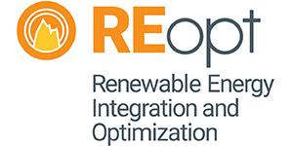

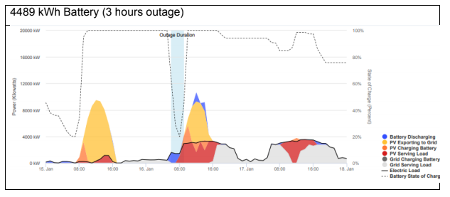

As you can see, the program gives the curve of the array system, the battery discharge and charging rate. With all this data we can have a more real situation on how the battery will behave in its worst-case scenario. We use this analysis so we can set a starting point on how it should look. Juan, Angel, and I started talking on how we can use monitors in OpenDss to plot and graph values and data and with that we could start doing the analysis. We discover that the monitor function has many modes that can be configured. The program can monitor voltages, power, current, transformer behavior and many more. With all this graph we could have a vast variety of information to make a good analysis in our part of the research paper. For next week Angel is going to search about mode 1 of the monitors, which was in the power graph. Juan and I are going to investigate more about mode 0, voltages and current, and mode 2, transformers.